**DAY-3 Assignment**

**Q1) Experiment on Andersbrownworth**

**Screenshot**

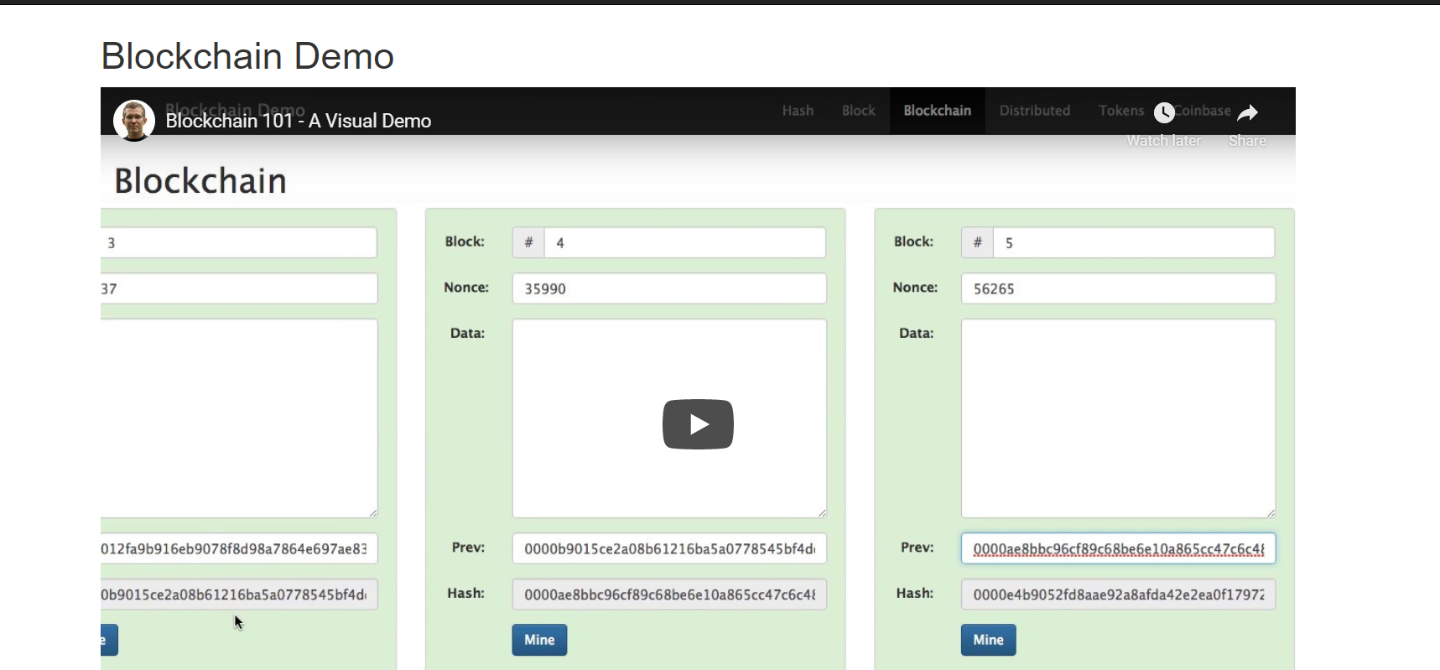

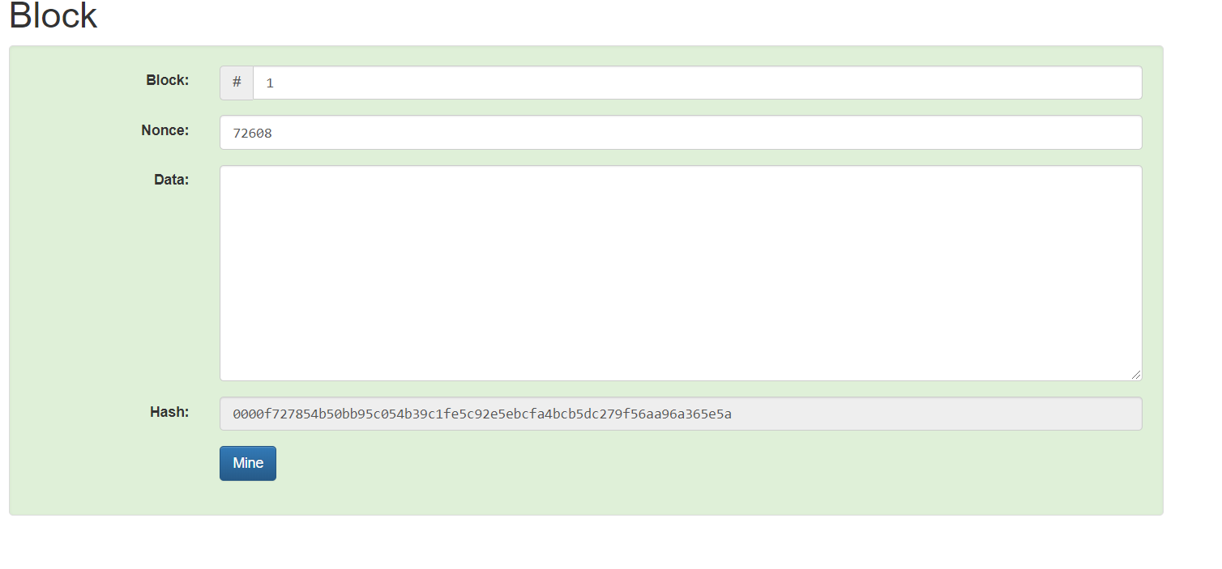

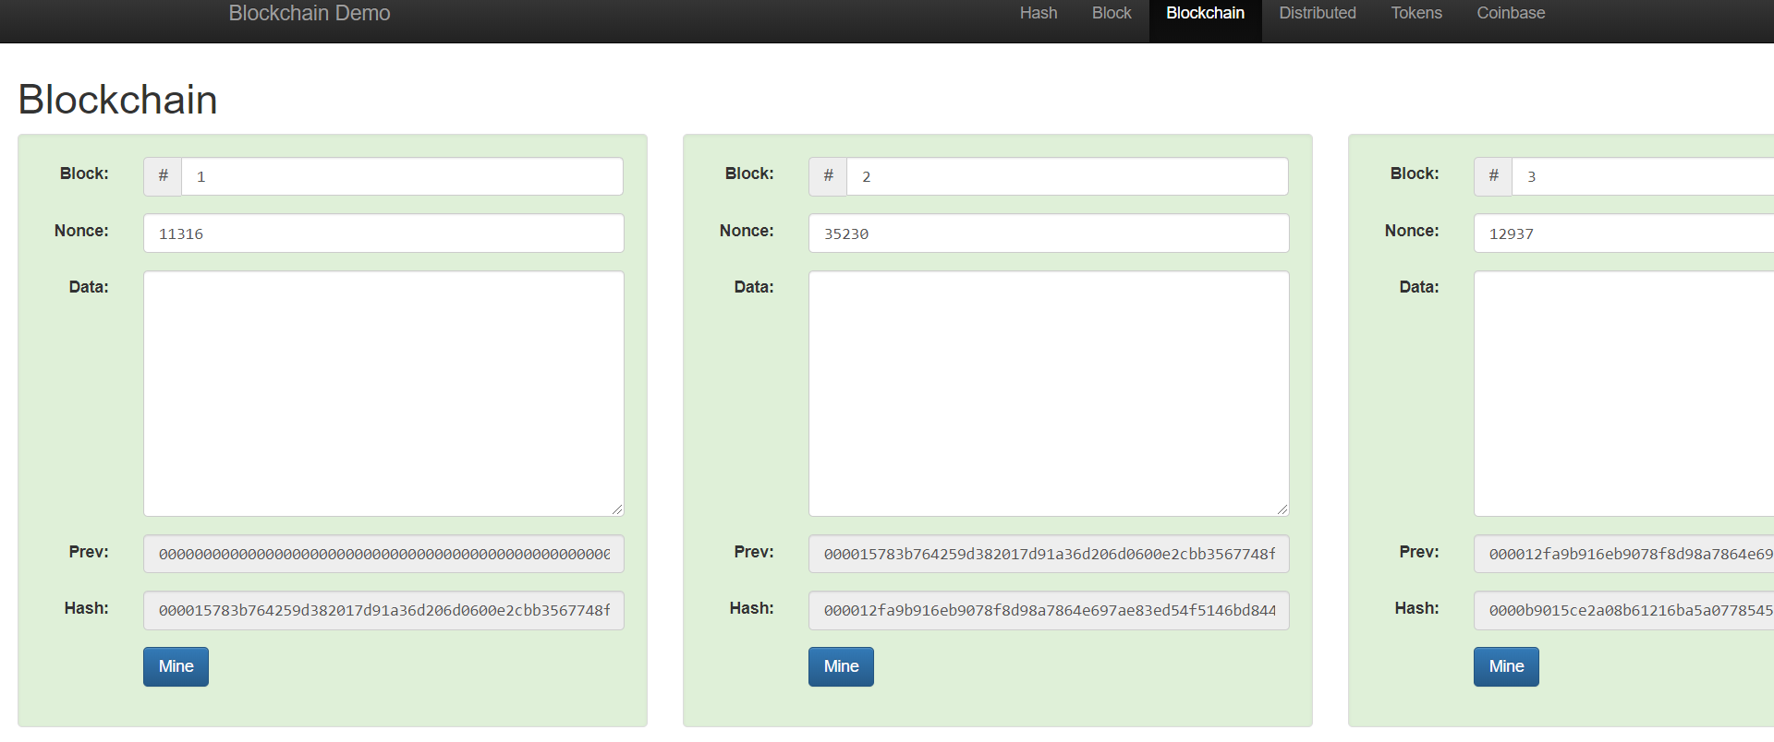

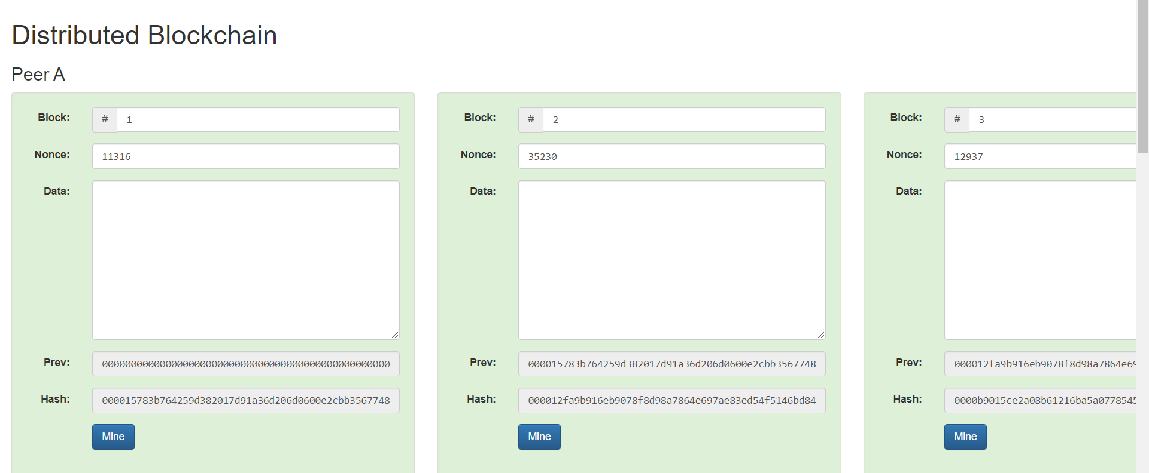

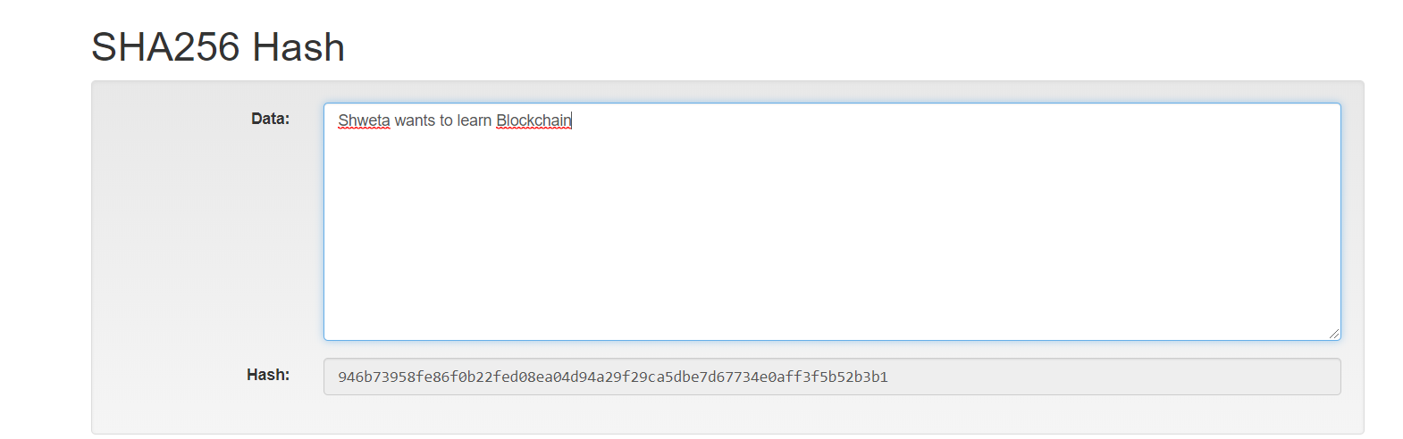

**Q2) Sample Contract example of Ballot.sol**

pragma solidity >=0.4.22 <0.7.0;

/**

* @title Ballot

* @dev Implements voting process along with vote delegation

*/

contract Ballot {

struct Voter {

uint weight; // weight is accumulated by delegation

bool voted; // if true, that person already voted

address delegate; // person delegated to

uint vote; // index of the voted proposal

}

struct Proposal {

// If you can limit the length to a certain number of bytes,

// always use one of bytes1 to bytes32 because they are much cheaper

bytes32 name; // short name (up to 32 bytes)

uint voteCount; // number of accumulated votes

}

address public chairperson;

mapping(address => Voter) public voters;

Proposal[] public proposals;

/**

* @dev Create a new ballot to choose one of 'proposalNames'.

* @param proposalNames names of proposals

*/

constructor(bytes32[] memory proposalNames) public {

chairperson = msg.sender;

voters[chairperson].weight = 1;

for (uint i = 0; i < proposalNames.length; i++) {

// 'Proposal({...})' creates a temporary

// Proposal object and 'proposals.push(...)'

// appends it to the end of 'proposals'.

proposals.push(Proposal({

name: proposalNames[i],

voteCount: 0

}));

}

}

/**

* @dev Give 'voter' the right to vote on this ballot. May only be called by 'chairperson'.

* @param voter address of voter

*/

function giveRightToVote(address voter) public {

require(

msg.sender == chairperson,

"Only chairperson can give right to vote."

);

require(

!voters[voter].voted,

"The voter already voted."

);

require(voters[voter].weight == 0);

voters[voter].weight = 1;

}

/**

* @dev Delegate your vote to the voter 'to'.

* @param to address to which vote is delegated

*/

function delegate(address to) public {

Voter storage sender = voters[msg.sender];

require(!sender.voted, "You already voted.");

require(to != msg.sender, "Self-delegation is disallowed.");

while (voters[to].delegate != address(0)) {

to = voters[to].delegate;

// We found a loop in the delegation, not allowed.

require(to != msg.sender, "Found loop in delegation.");

}

sender.voted = true;

sender.delegate = to;

Voter storage delegate_ = voters[to];

if (delegate_.voted) {

// If the delegate already voted,

// directly add to the number of votes

proposals[delegate_.vote].voteCount += sender.weight;

} else {

// If the delegate did not vote yet,

// add to her weight.

delegate_.weight += sender.weight;

}

}

/**

* @dev Give your vote (including votes delegated to you) to proposal 'proposals[proposal].name'.

* @param proposal index of proposal in the proposals array

*/

function vote(uint proposal) public {

Voter storage sender = voters[msg.sender];

require(sender.weight != 0, "Has no right to vote");

require(!sender.voted, "Already voted.");

sender.voted = true;

sender.vote = proposal;

// If 'proposal' is out of the range of the array,

// this will throw automatically and revert all

// changes.

proposals[proposal].voteCount += sender.weight;

}

/**

* @dev Computes the winning proposal taking all previous votes into account.

* @return winningProposal_ index of winning proposal in the proposals array

*/

function winningProposal() public view

returns (uint winningProposal_)

{

uint winningVoteCount = 0;

for (uint p = 0; p < proposals.length; p++) {

if (proposals[p].voteCount > winningVoteCount) {

winningVoteCount = proposals[p].voteCount;

winningProposal_ = p;

}

}

}

/**

* @dev Calls winningProposal() function to get the index of the winner contained in the proposals array and then

* @return winnerName_ the name of the winner

*/

function winnerName() public view

returns (bytes32 winnerName_)

{

winnerName_ = proposals[winningProposal()].name;

}

}

**Screenshot**

